Practical Massage Techniques 4

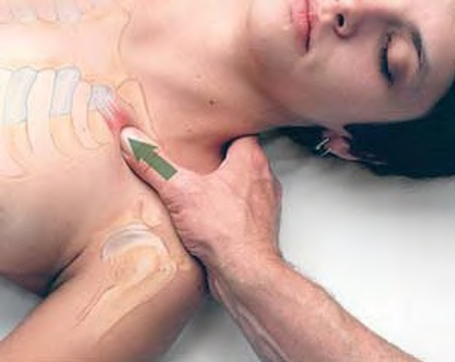 Stripping massage of subclavius
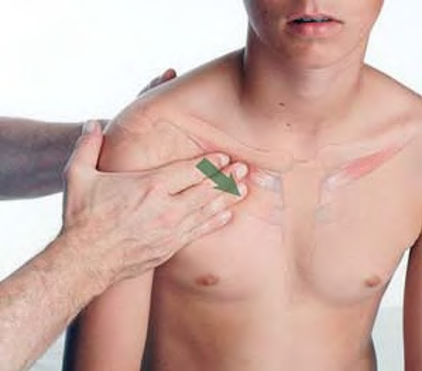 Stripping of subclavius in sitting position
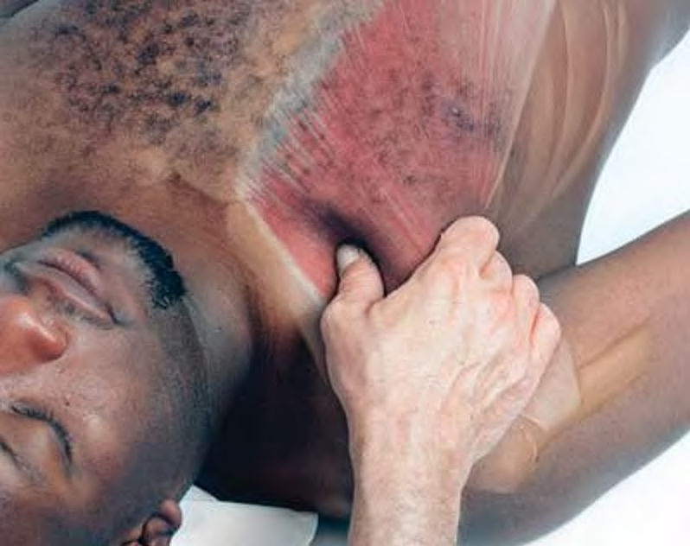 Pincer compression of pec major
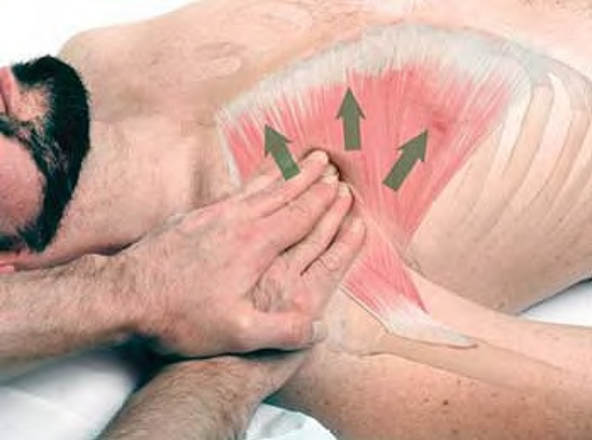 Stripping massage of pectoralis major
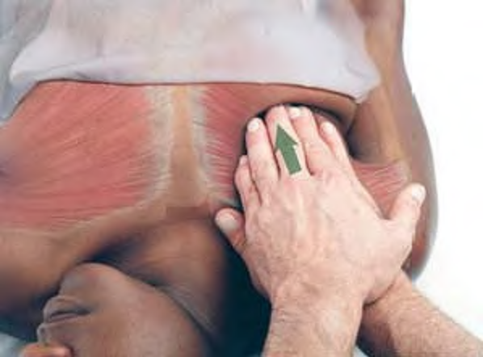 Treatment of pectoralis major in a female
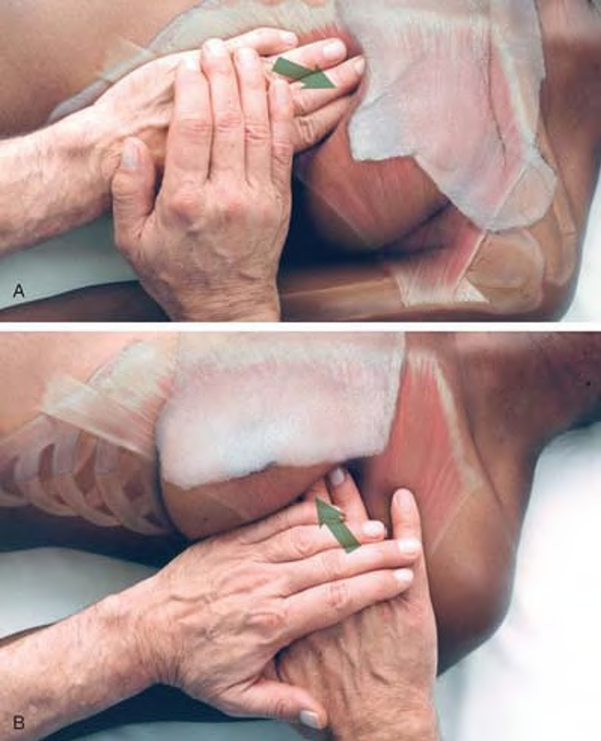 Compression of pectoralis major in a female client: medial inferior portion (A), lateral portion (B)
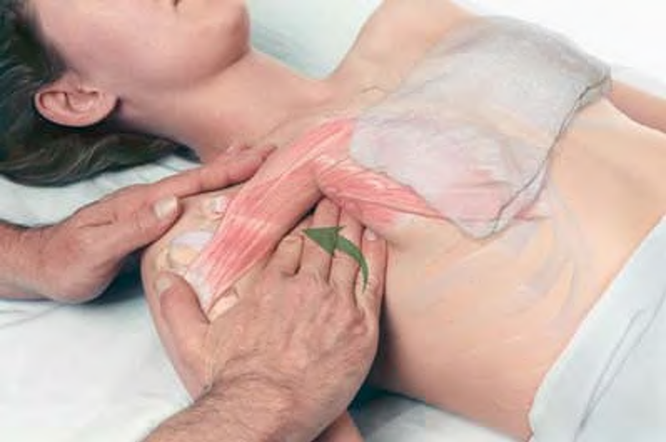 Treatment of pectoralis minor in supine position

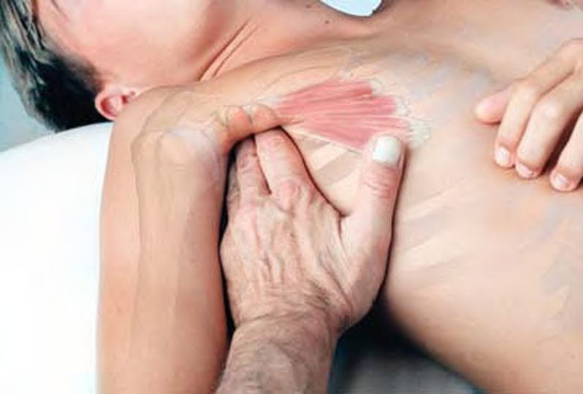 Compression of pectoralis minor attachment to coracoid process

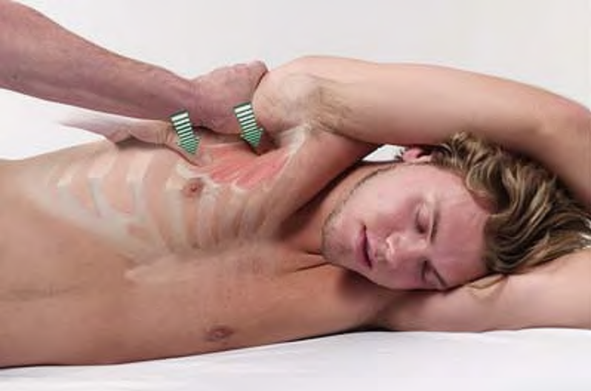 Treating pectoralis minor in sidelying position

Sidelying treatment of pec minor from behind client from starting (A) to final position (B)

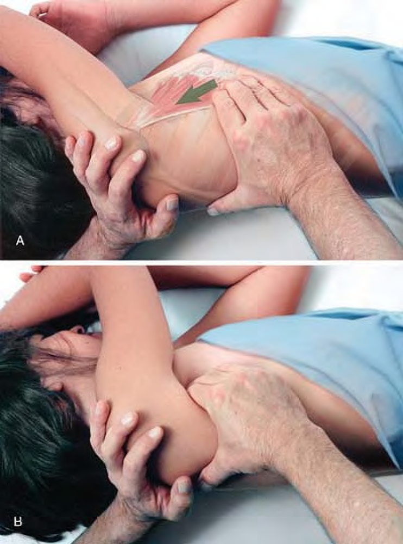

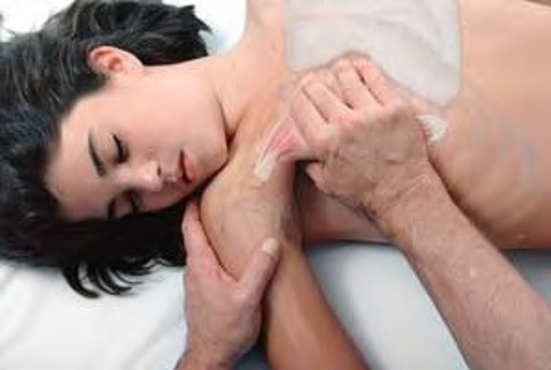 Compression of pectoralis minor with thumb

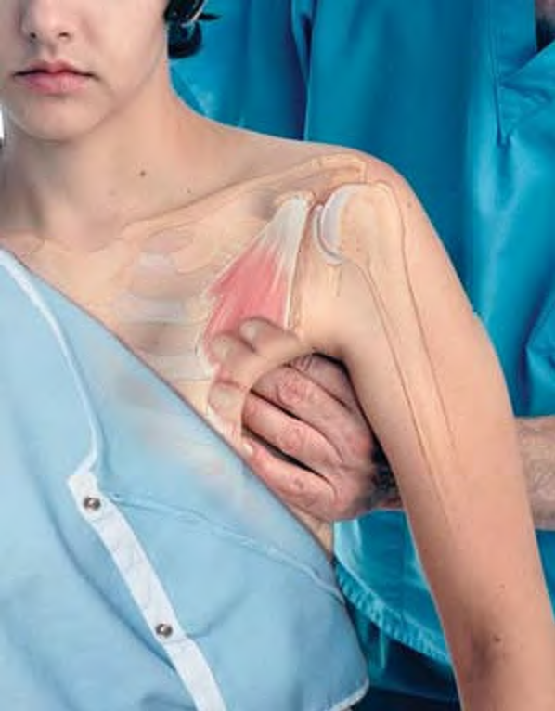 Compression of pectoralis minor on seated client

