Practical Massage Techniques 3

Posterior Neck Muscles
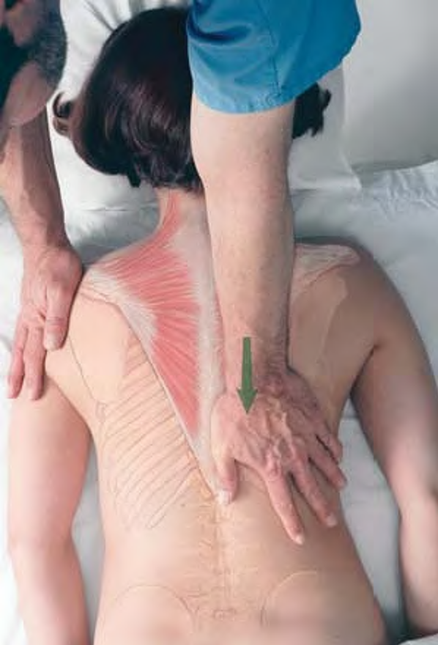 Deep stripping of trapezius
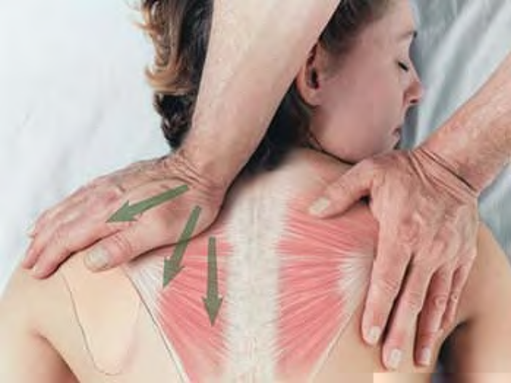 Deep stripping of superolateral trapezius
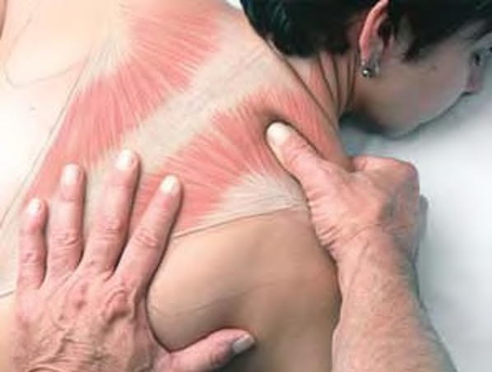 Pincer compression of trapezius
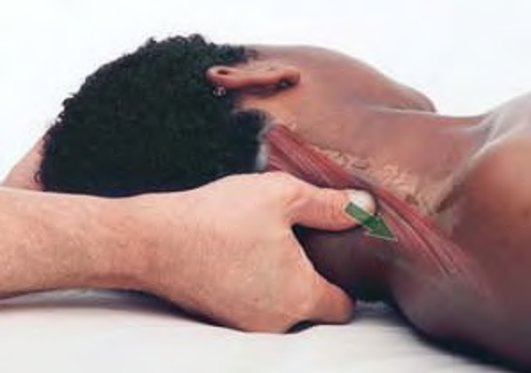 Stripping of posterior neck muscles with thumb
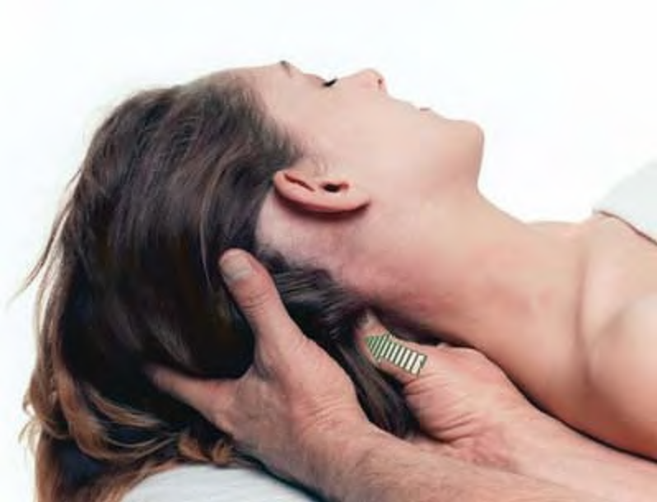 Compression of suboccipital muscles
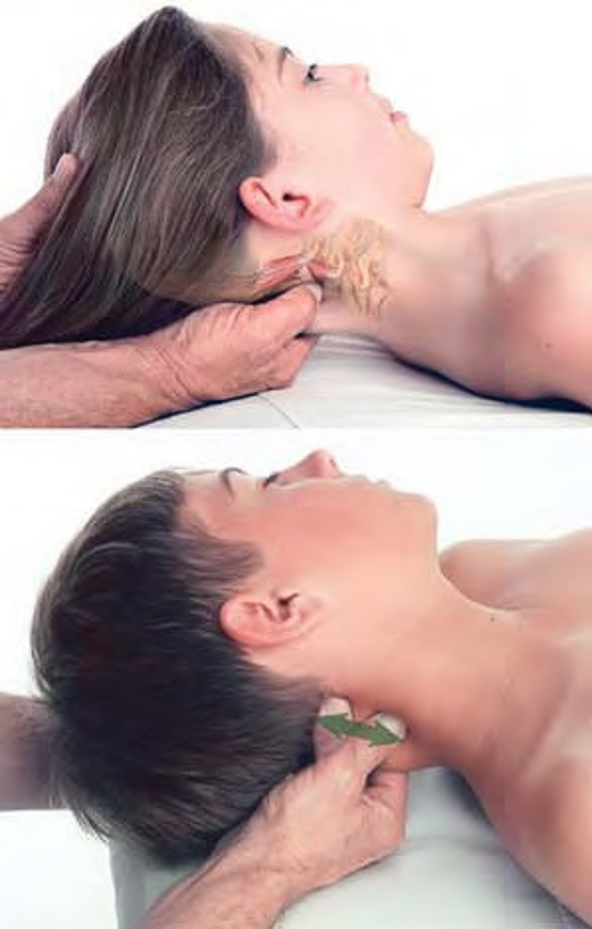 Bidirectional stripping of posterior neck muscles with thumb

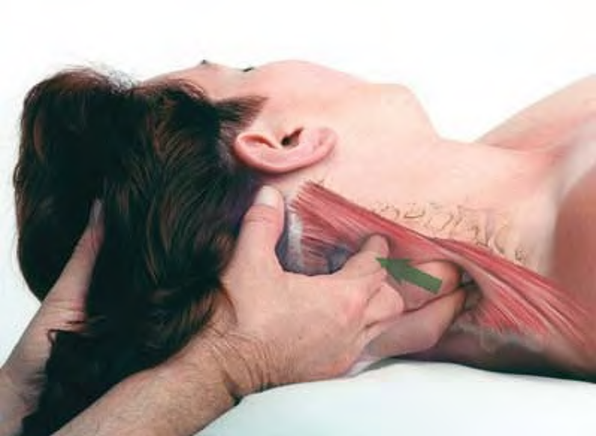 Stripping of posterior neck muscles with fingertips
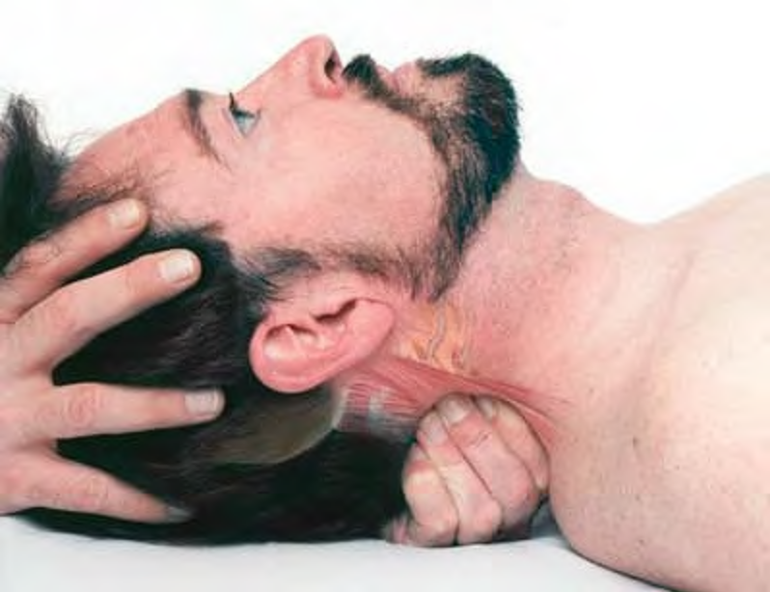 Cross-fiber stroking of posterior neck muscles with fingertips
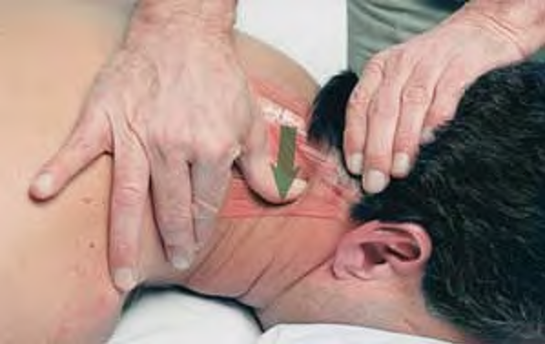 Cross-fiber stroking on posterior neck muscles with the thumb

