Joint Play Manual 1

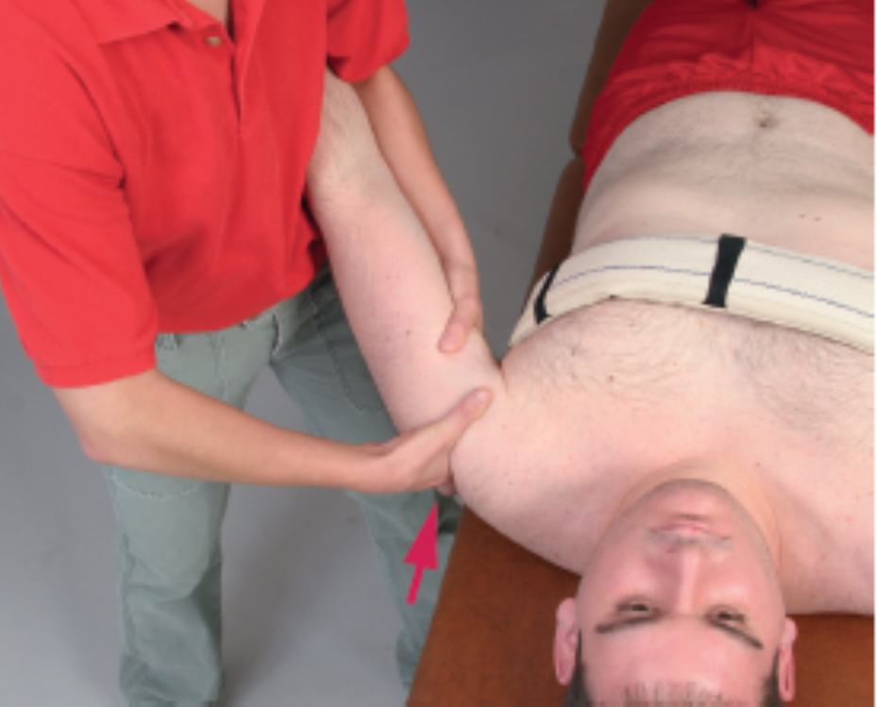
Glenohumeral Axial Distraction 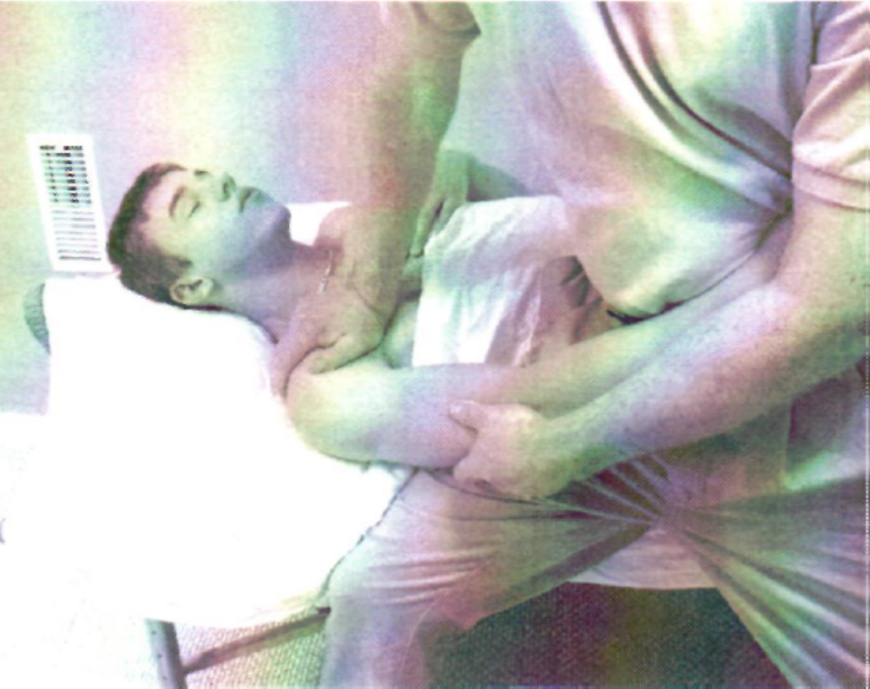
Glenohumeral joint Lateral Distraction 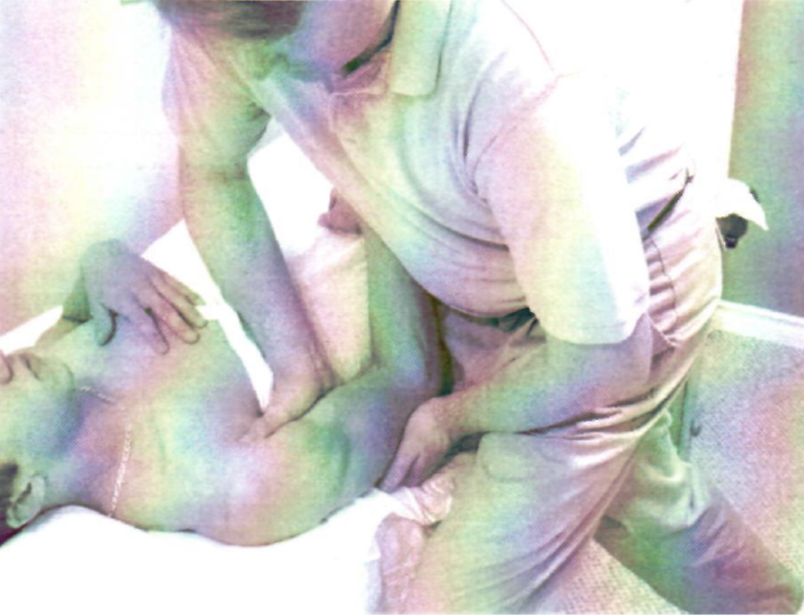
Glenohumeral Posterior Glide 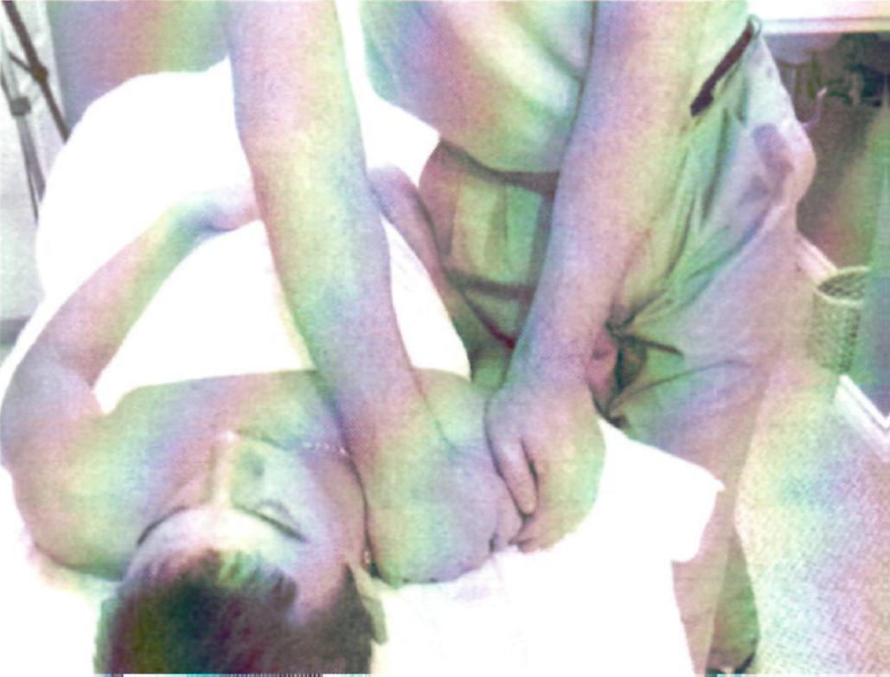
Glenohumeral Anterior Glide 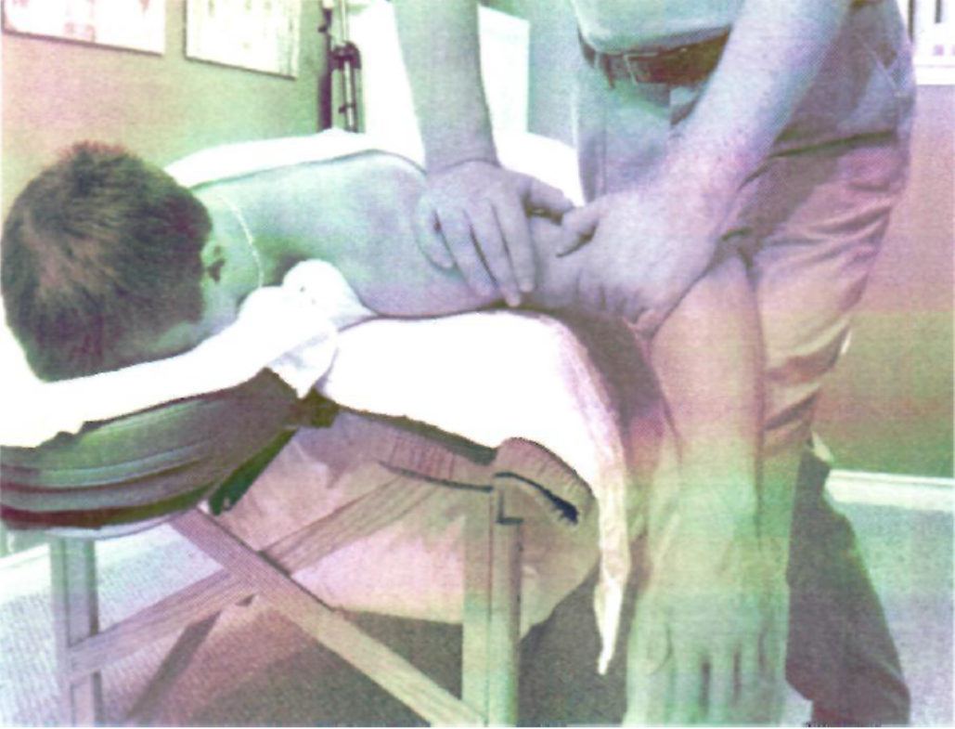
Glenohumeral Inferior Glide 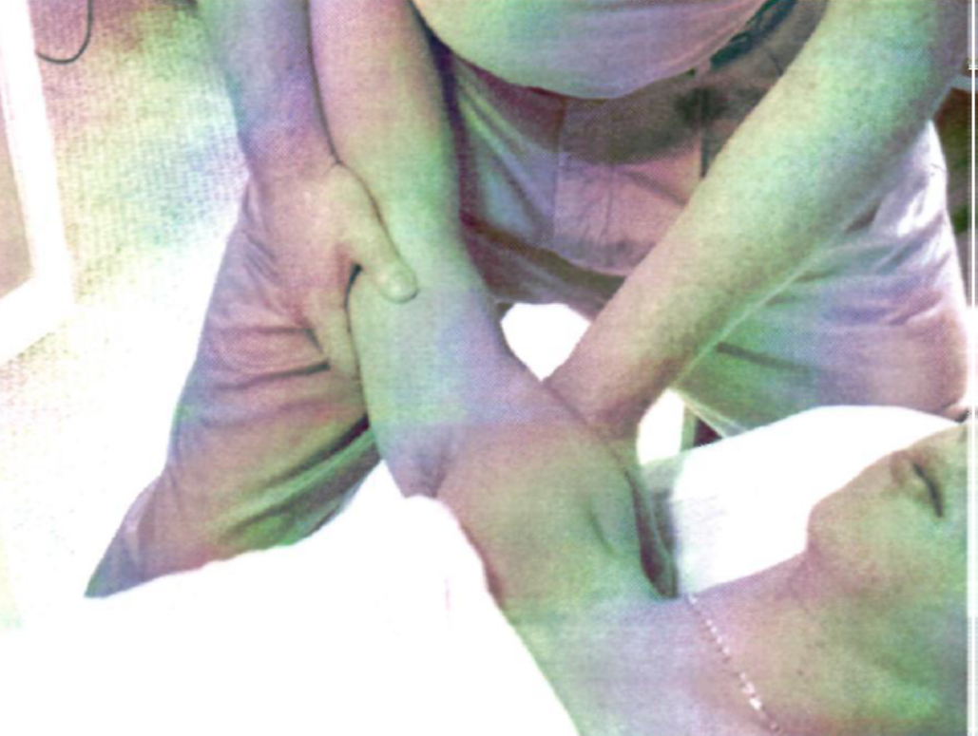
Humeroulnar Joint Distraction 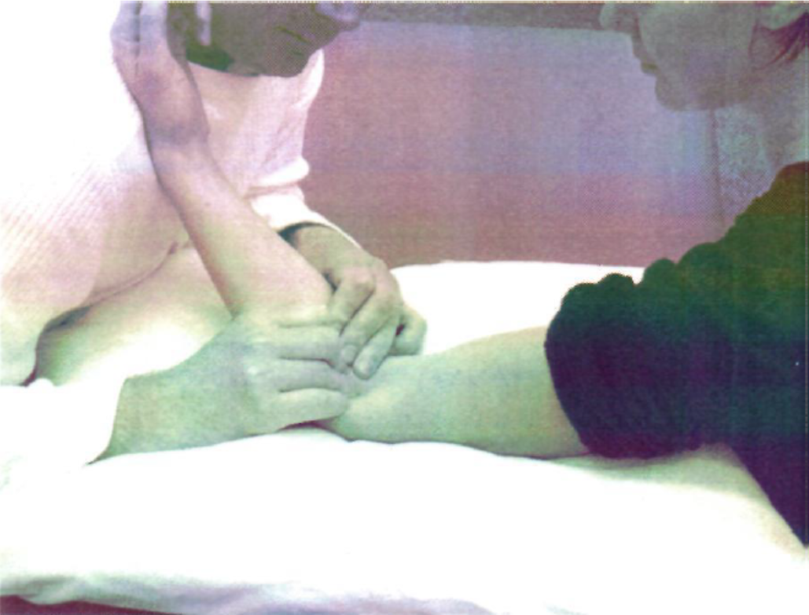
Humeroulnar Joint Lateral Gap 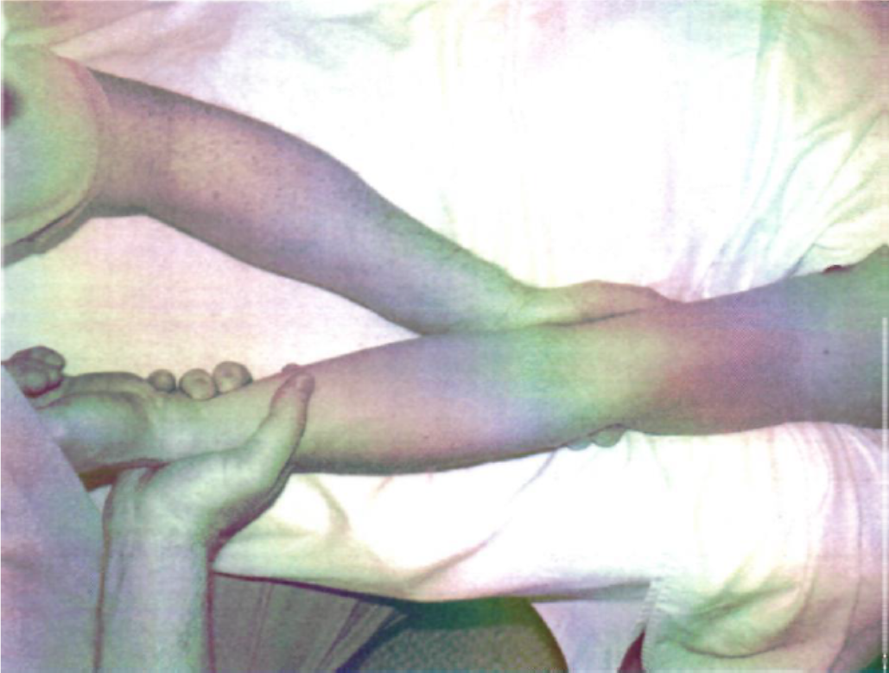
Humeroulnar Joint Medial Gap 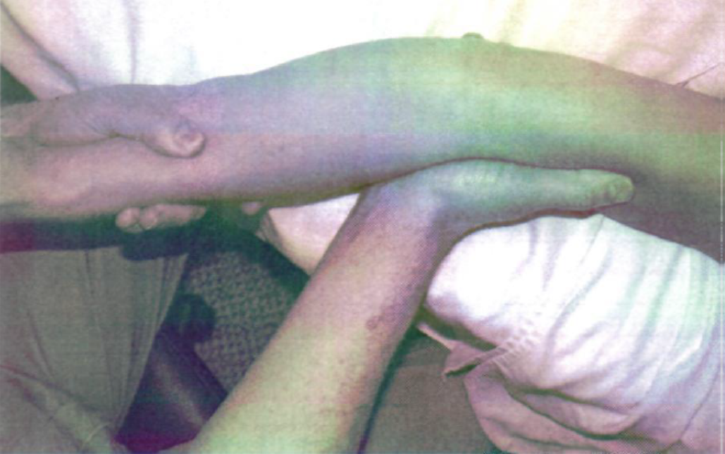
Humeroulnar Joint Lateral Glide 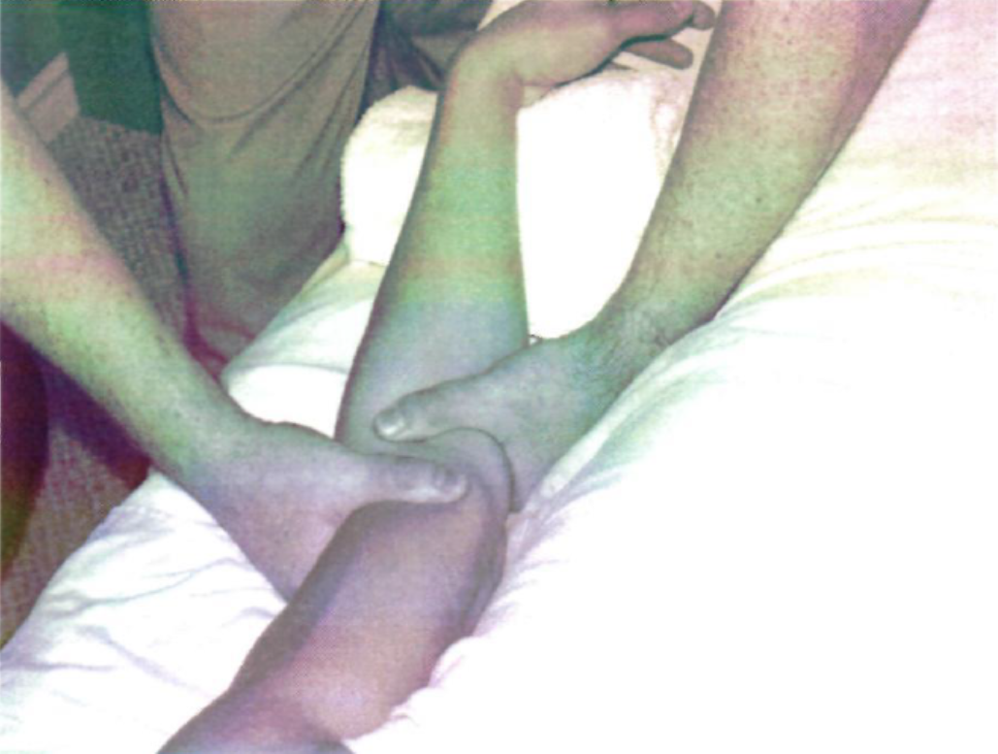
Humeroulnar Joint Medial Glide 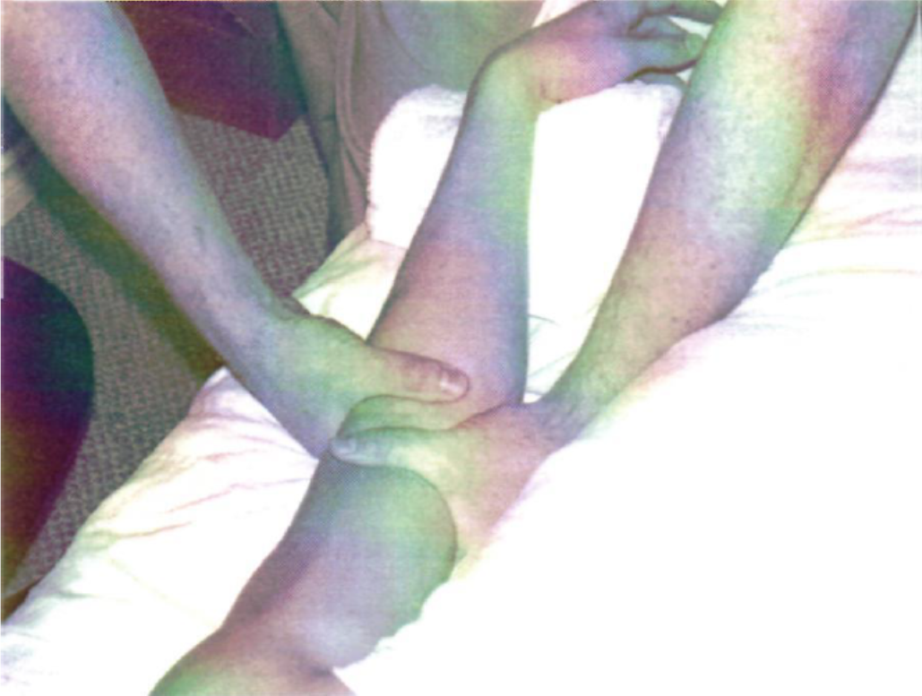
Proximal Radioulnar Joint Anterior Glide 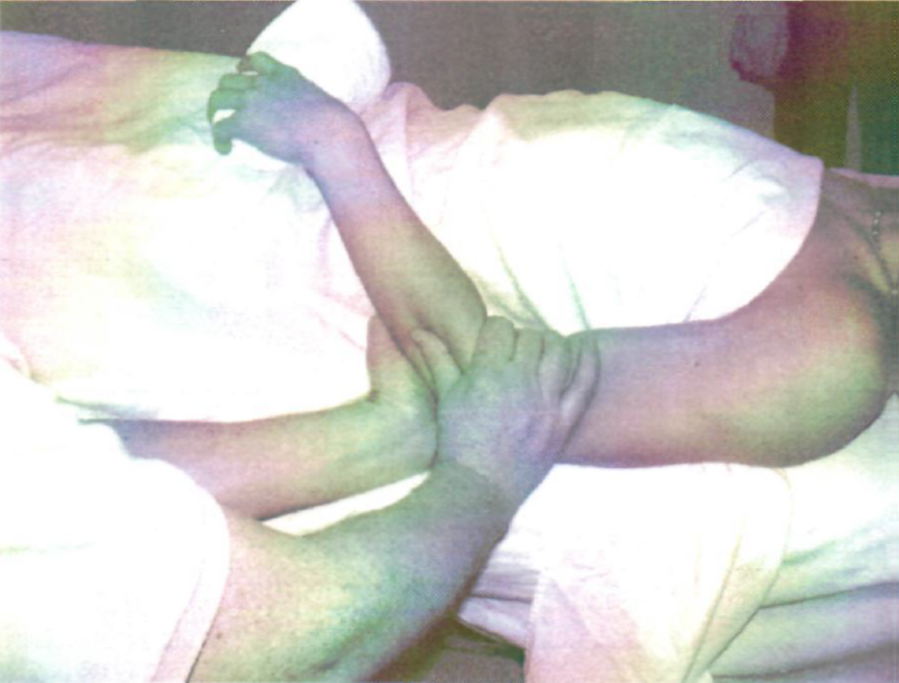
Proximal Radioulnar Joint Posterior Glide 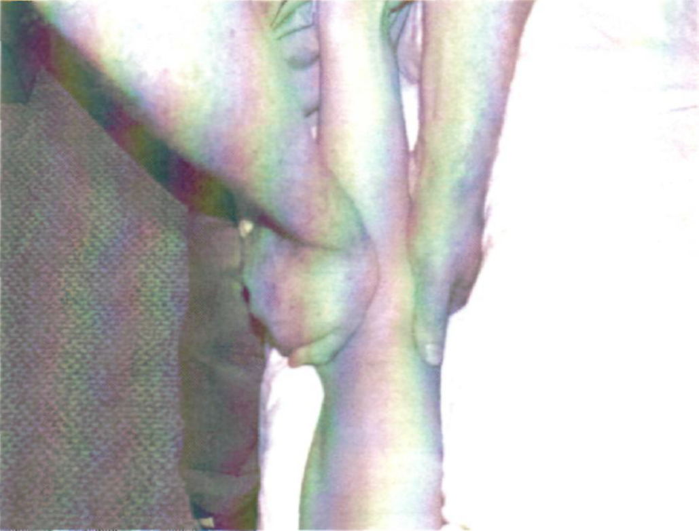
Humeroradial Joint Distraction 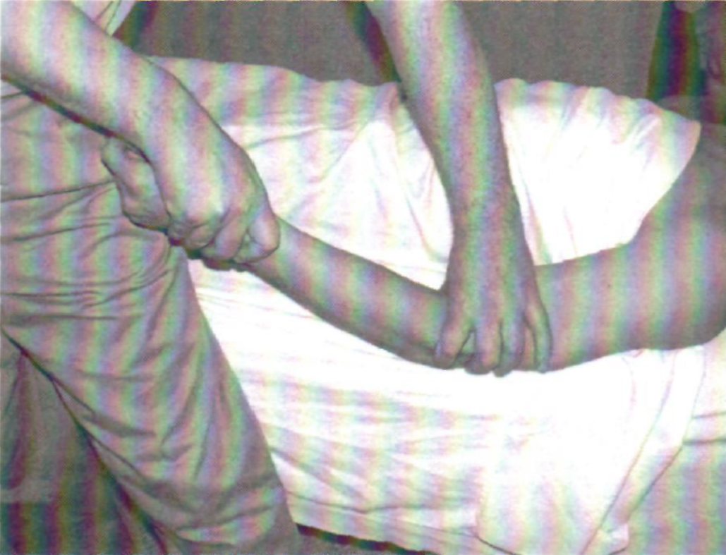
Humeroradial Joint Posterior Glide 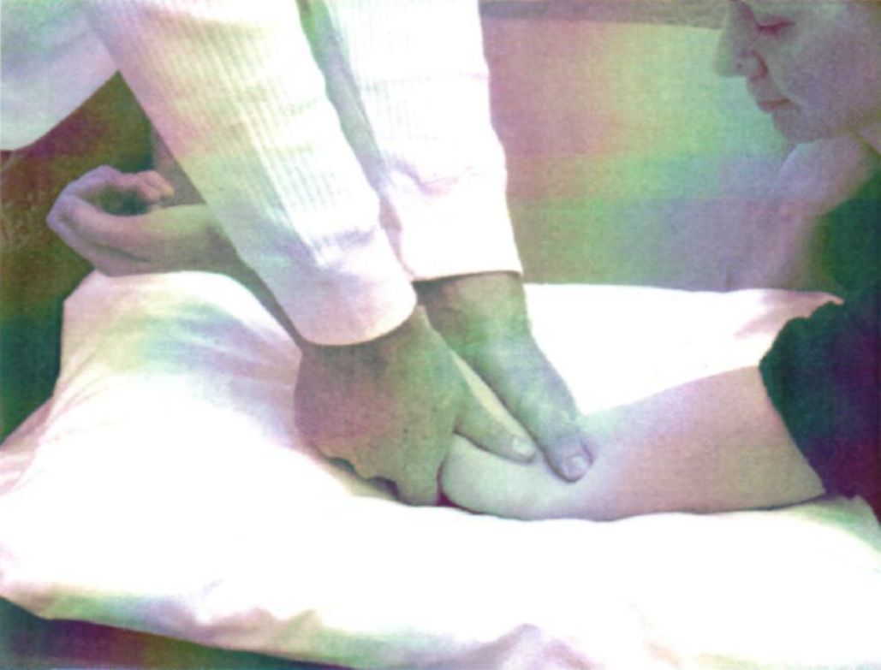
Humeroradial Joint Anterior Glide 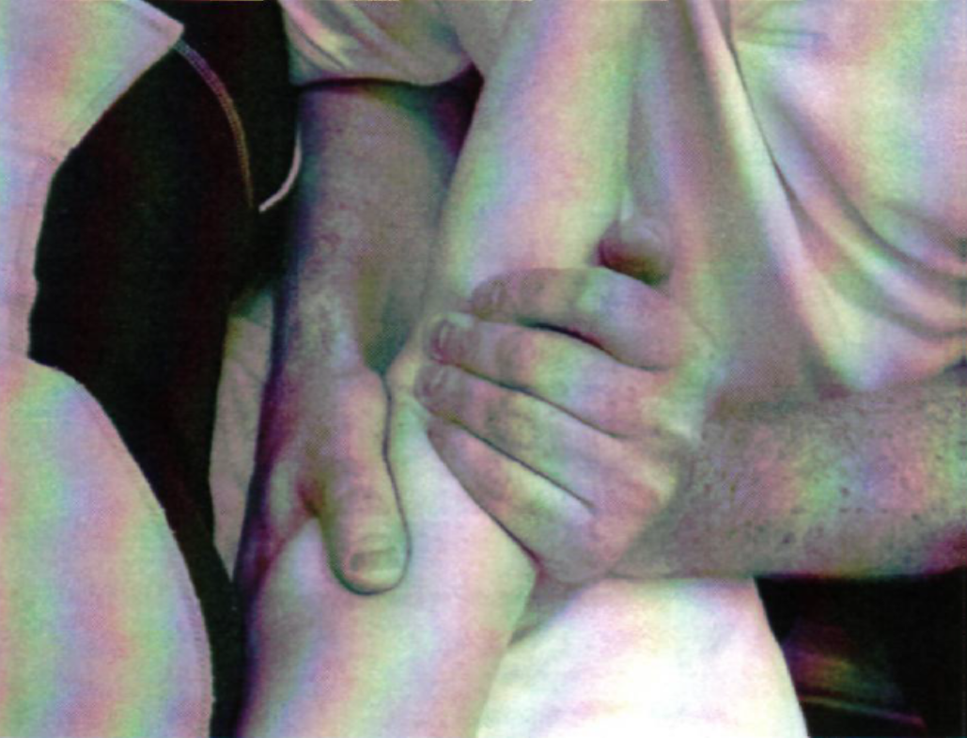
Distal Radioulnar Joint Anterior & Posterior Glide 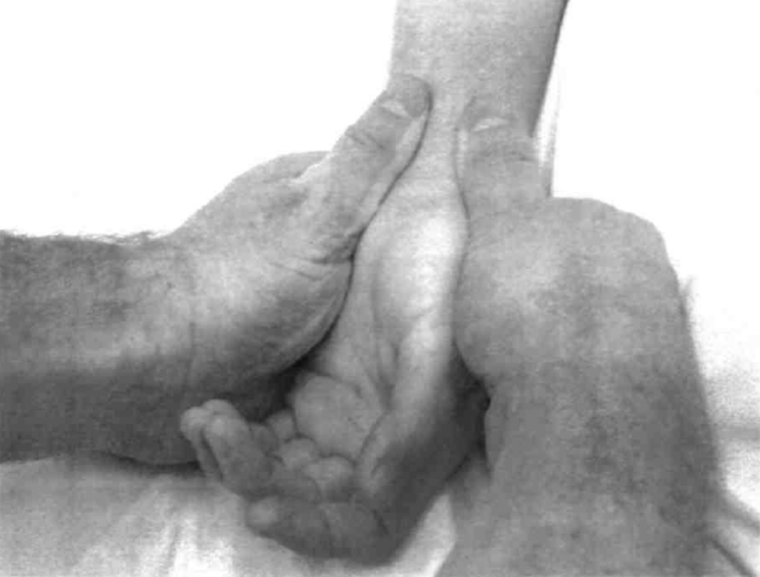
Radiocarpal Joint Distraction 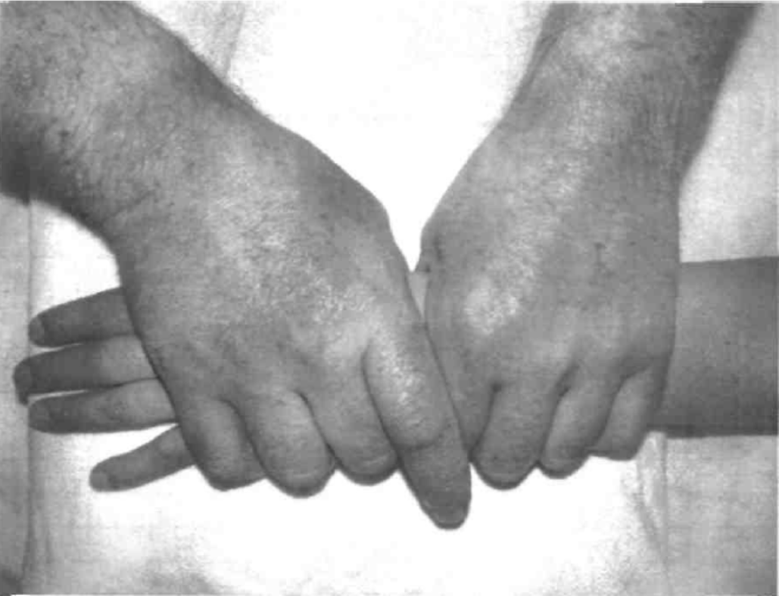
Radiocarpal Joint Palmar Glide 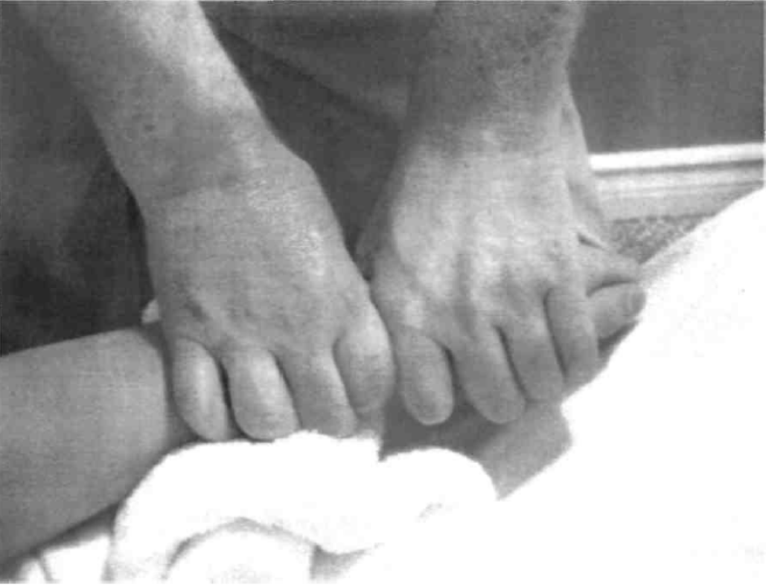
Radiocarpal Joint Dorsal Glide 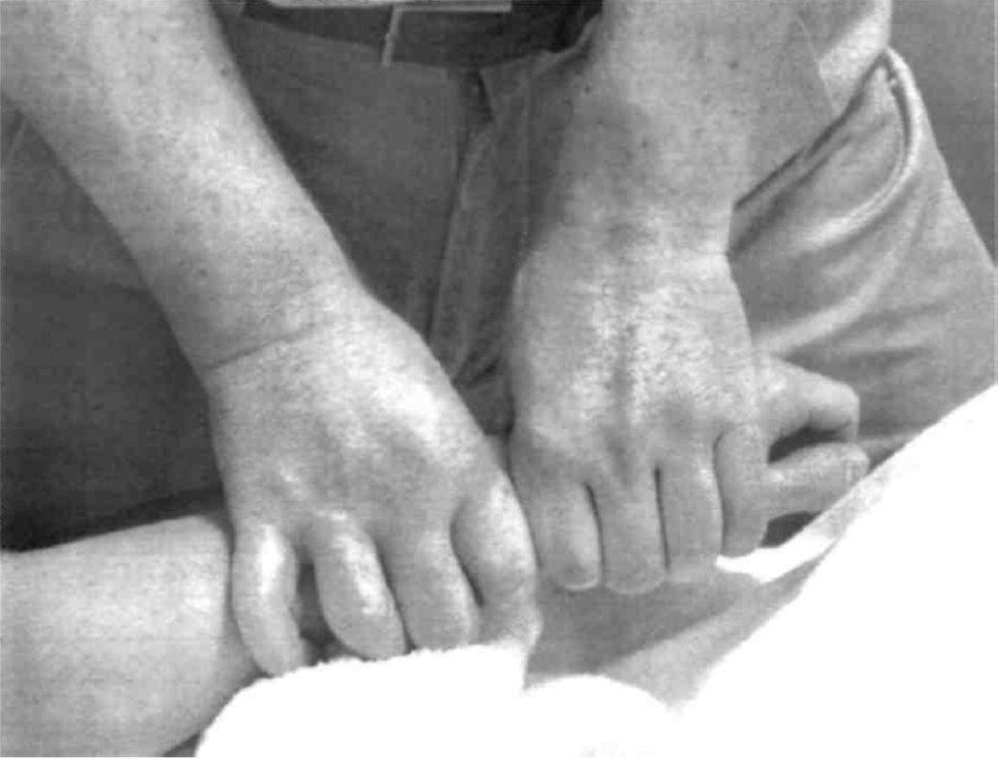
Radiocarpal Joint Radial Glide 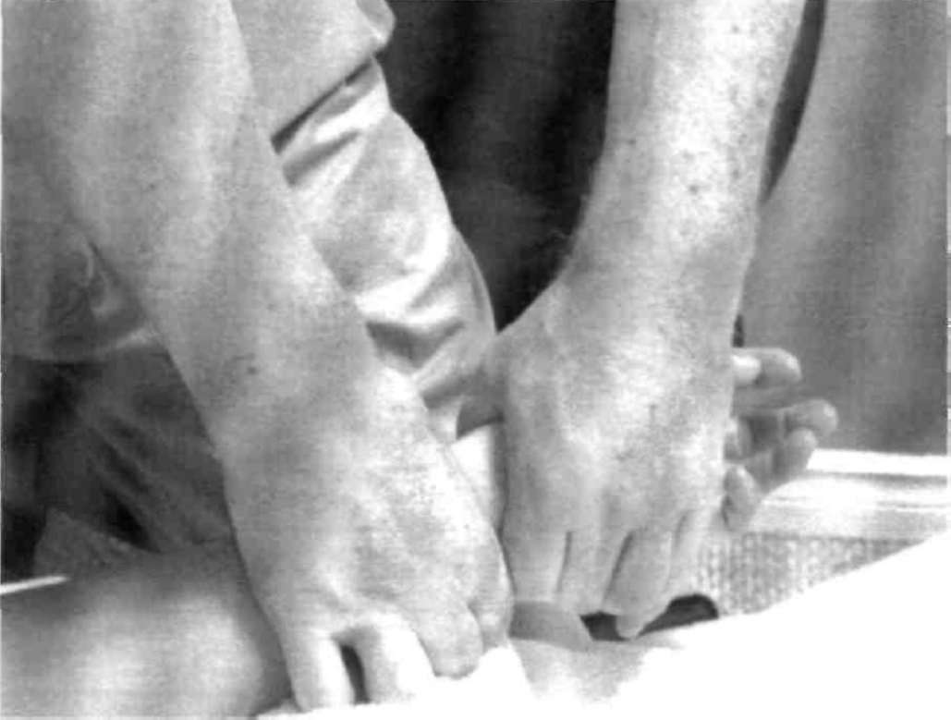
Radiocarpal Joint Ulnar Glide 