5.Golfer’s elbow (supine )

1. Trp: Biceps brachii
2. Friction On wrist common flexors tendon
3. JP: G3 Distraction humeroulnar joint (increase overall ROM)

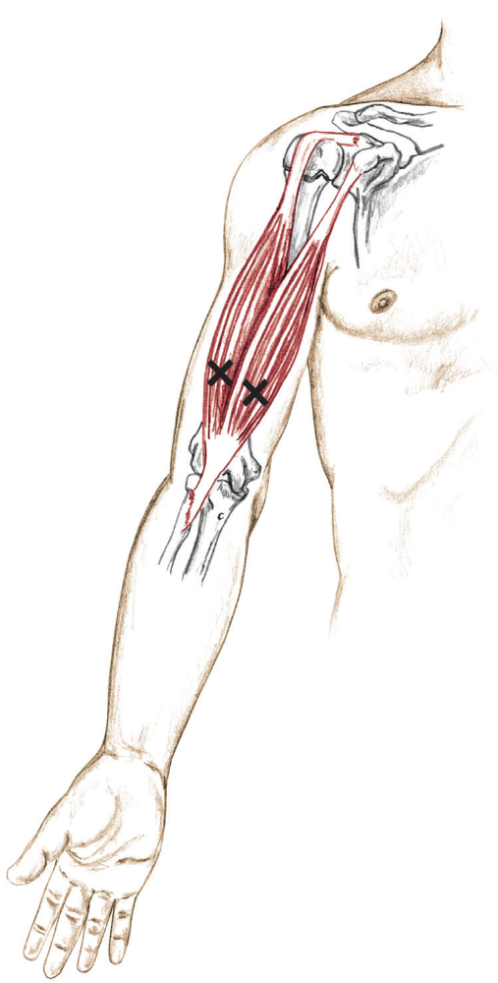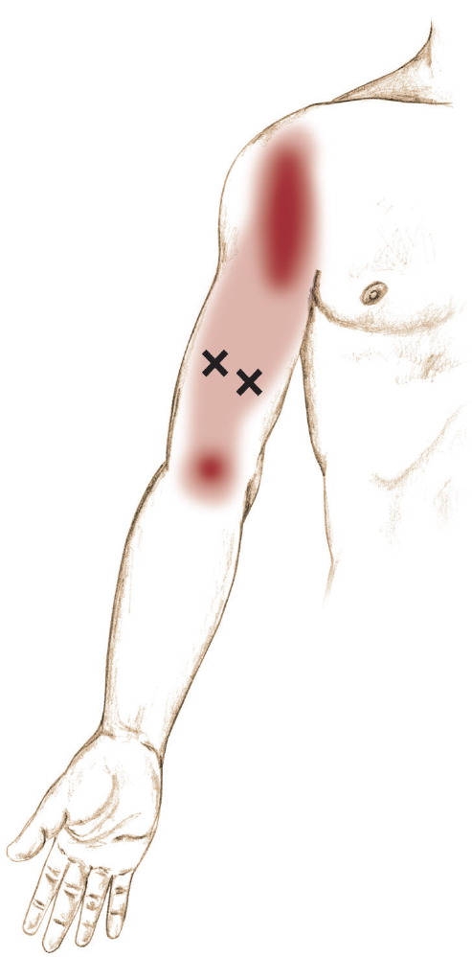

1. Trp: biceps brachii

Script:
1. I am going to work trigger point on your biceps brachii.
2. Please take deep breath in and out, Start Effleurage and petrissage stripping or kneading from light to deep, Now I am going to
increase the pressure. now warm up already.
3. Let me feel your muscle fibres, please do against me. ok I am finding your taut band and relax.
3. I am start using ischemic compression to reduce it. Can you scale the pain for me 0 - 10? Keep compression for 1minute. Is it pain is local or remote other area?
“This ischemic compression can break down the taut band and reduce myofascial pain and increase movement.”
4. Let me know when the pain diminished ok? Time up
5. flush out the area for 30 second to remove the toxins.
6. Follow by heating pad and passive stretch.

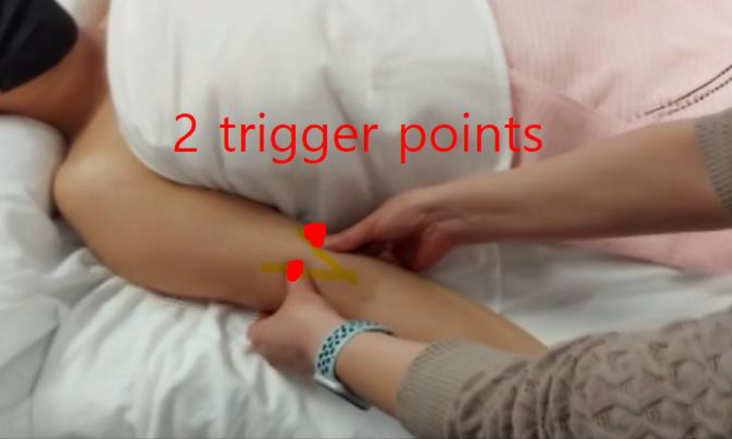
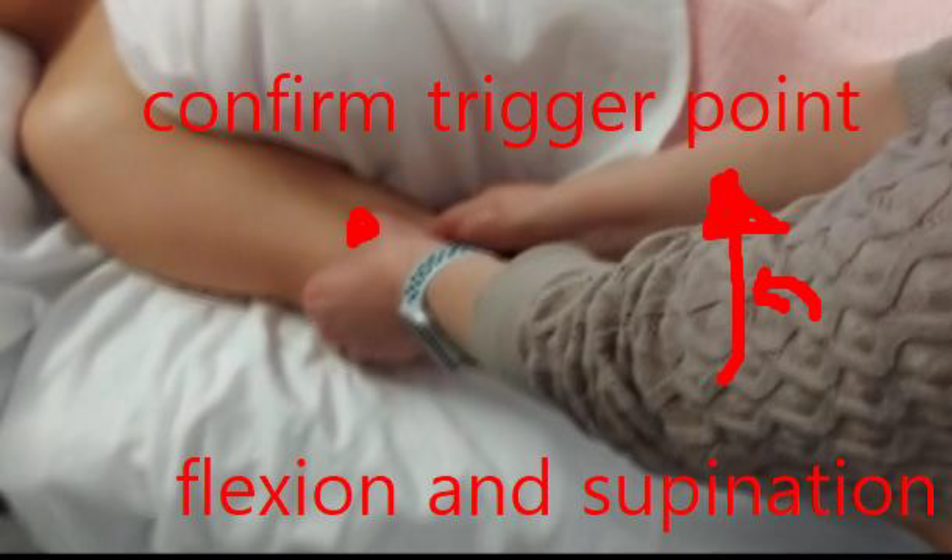
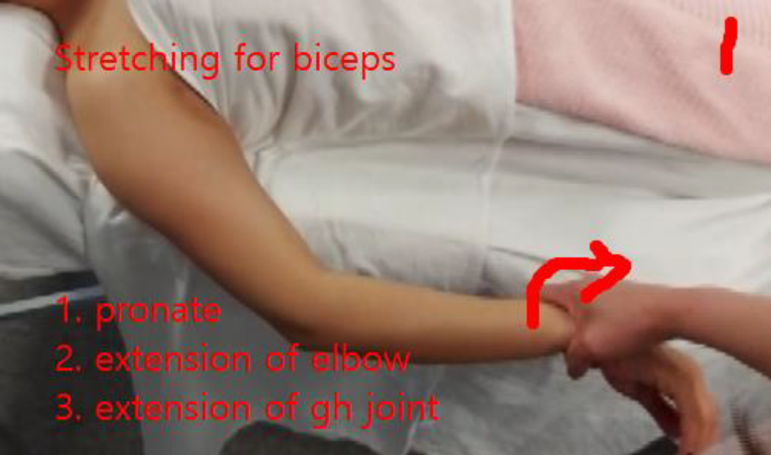
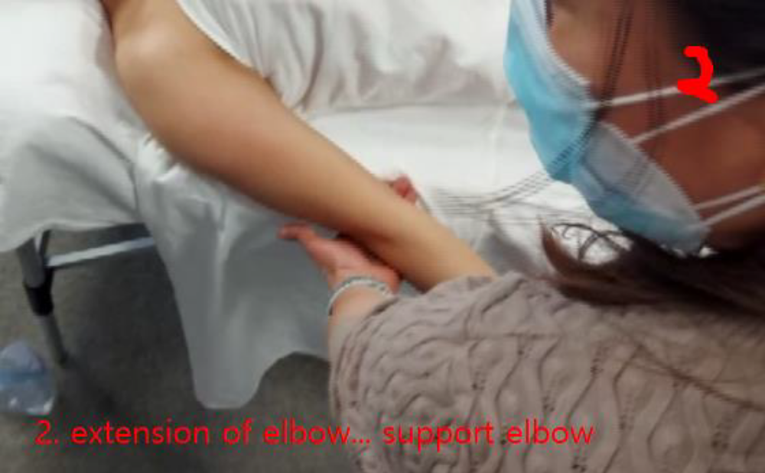
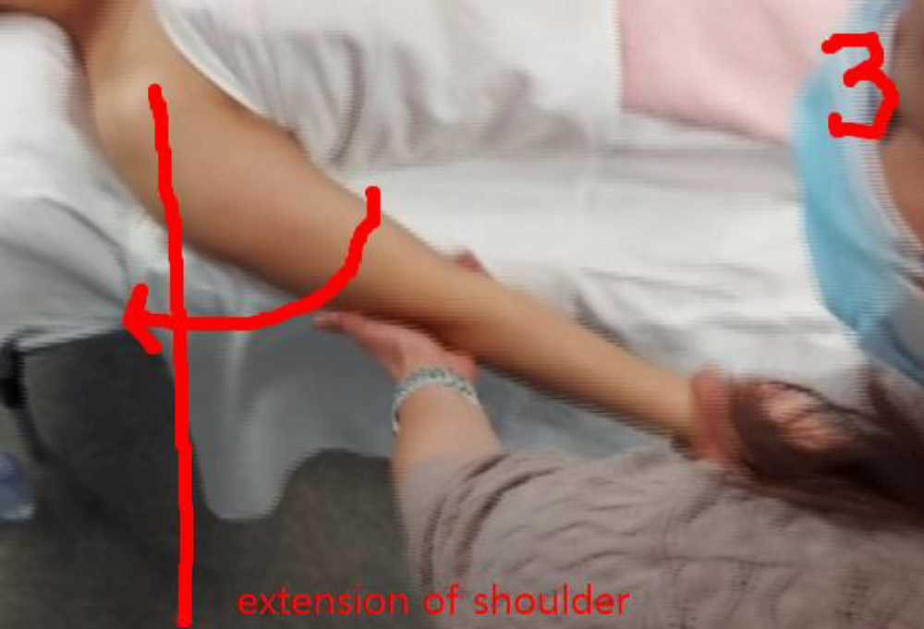

2. Friction on wrist common flexors tendon

1. I am going to do friction
2. First let me warm up your muscle. Please take deep breathing in and out. Effleurage muscle stripping kneading …muscle is already warm up.
2. Let me remove the oil from your body and my hand too
3. let me assess your common flexors tendon, please do this, move against me … and relax
4. This friction is very painful technique. May I have your extra consent to do it
5. Now I am going to do cross fibre friction for you. Does this pain tolerable? Start the cross friction. Does the pain tolerable?
“Friction can break down adhesion and reduce the myofascial pain.”
6. Usually, I do this friction for two minutes and up to three times.
7. Let me flush the area for 30 second
8. And then ice pad and passive stretch, I will do it.
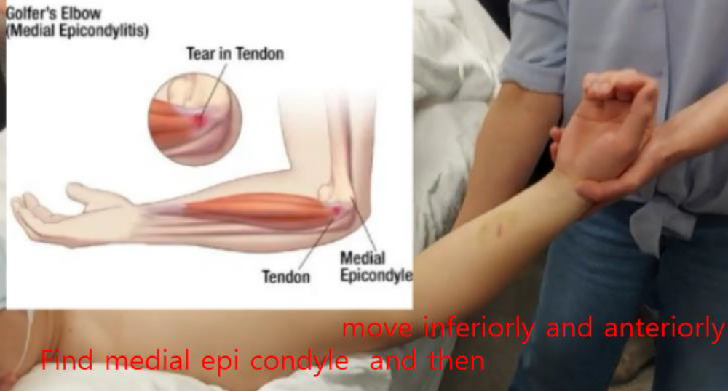

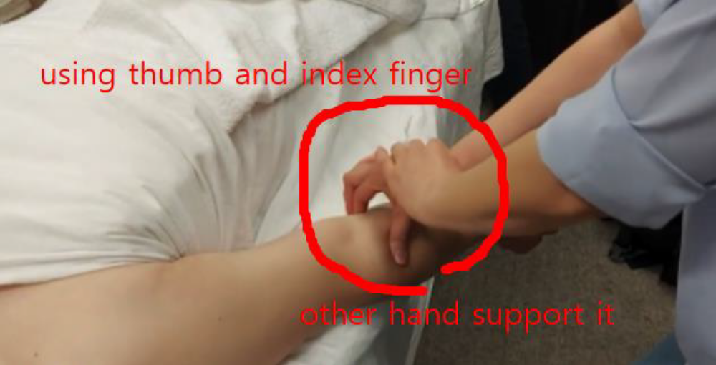
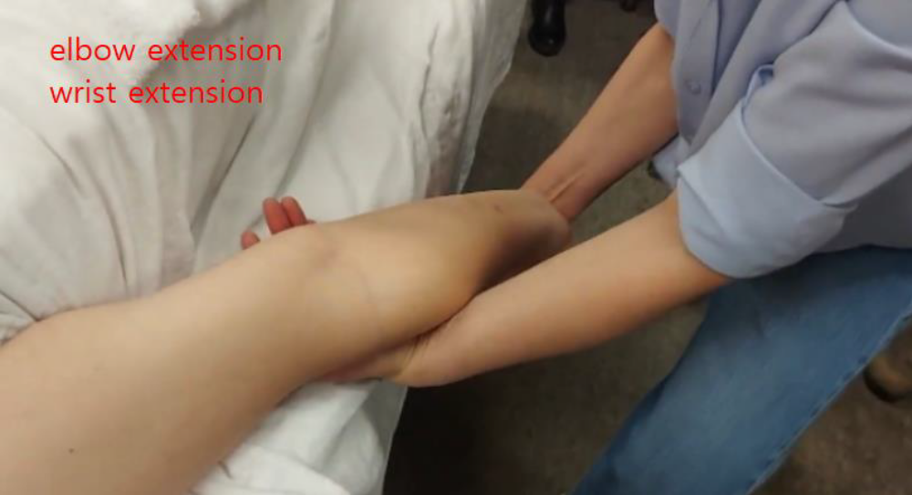

3. JP: G3 distraction humeroulnar joint (increase overall ROM)

1. I am going to do G3 distraction. This joint locates on elbow
2. First, put the towel under elbow. I am going to distraction. make 70-degree flexion for open packed position
3. For (G3 or G2 glide) just hold for 6 second repeat three time
“This joint play can loose up joint capsule increase mobility or joint movement.”
4. Relax. Now I am finishing the joint play.
5. First, rotate and then push down, four fingers cross together, Thumbs put on the ulnar bone

